IT5512- WEB TECHNOLOGY LAB-SESSION-5
DATE: 04/10/2021
NAME: A.S. PRUTHIEV
REG NO.2019506067
SOCKET PROGRAMMING
1)AIM:
To write a Java Program for implementing echo client and echo server interaction (Two -way communication) via TCP Protocol
ALGORITHM:
Client Side:
- Create an object of the socket class and an ArrayList of integers

- Read the n elements to the ArrayList

- Create an object of the OutputStreamAbstractClass and ObjectOutputStream class to send the array List to the output port of the Server.

- When the control reaches back to the client again display the result (i.e., the sum)

Server Side :
- Create a ServerSocket class and mention the port number (same as the one used in client file)

- Use the InputStreamAbstractClass and InputStream classes to receive and type cast to the appropriate data type and calculate the sum and send it back to the client

PROGRAM CODE:
Client Code:
package Java.SocketProgramming;

import java.io.InputStream;
import java.io.ObjectInputStream;
import java.io.ObjectOutputStream;
import java.io.OutputStream;
import java.net.Socket;
import java.util.ArrayList;
import java.util.Scanner;

public class TwoWayCommunicationClient {
private static Scanner input = new Scanner(System.in);
public static void main(String[] args) throws Exception {
String ipAddress = "192.168.1.18";
int portNumber = 9999;
Socket clientSocket = new Socket(ipAddress,portNumber);
int n;
System.out.print("Enter the number of elements :");
n = input.nextInt();
ArrayList<Integer>values = new ArrayList<>(n);
System.out.print("Enter values :");
for(int i = 0,j ; i < n ; i++){
j = input.nextInt();
values.add(j);
}
OutputStream outputStream = clientSocket.getOutputStream();
ObjectOutputStream objectOutputStream = new ObjectOutputStream(outputStream);
System.out.println("The client writes the data");
objectOutputStream.writeObject(values);
InputStream inputStream = clientSocket.getInputStream();
ObjectInputStream objectInputStream = new ObjectInputStream(inputStream);
System.out.println("The client reads the sum from server ");
Integer sum = (Integer) objectInputStream.readObject();
System.out.println("The sum of the values are :" + sum);

}
}
Server Code:
package Java.SocketProgramming;

import java.io.*;
import java.net.ServerSocket;
import java.net.Socket;
import java.util.ArrayList;
import java.util.Arrays;
import java.util.List;
import java.util.stream.Stream;
public class TwoWayCommunicationServer {
public static void main(String[] args) throws Exception{
System.out.println("The server is started ");
ServerSocket serverSocket = new ServerSocket(9999);
System.out.println("Server is waiting to receive the data");
Socket socket = serverSocket.accept();
InputStream inputStream = socket.getInputStream();
ObjectInputStream objectInputStream = new ObjectInputStream(inputStream);
System.out.println("Server reads the data");
List<Integer> values = (List<Integer>)objectInputStream.readObject();
System.out.print("The data read is :");
values.forEach(x -> System.out.print(x + " "));
System.out.println();
Integer sumValues = values.stream().mapToInt(x -> x).sum();
System.out.println("The sum is calculted ");
OutputStream outputStream = socket.getOutputStream();
ObjectOutputStream objectOutputStream = new ObjectOutputStream(outputStream);
System.out.println("The server writes into the client ");
objectOutputStream.writeObject(sumValues);
}
}
OUTPUT:
Initial run of the server:
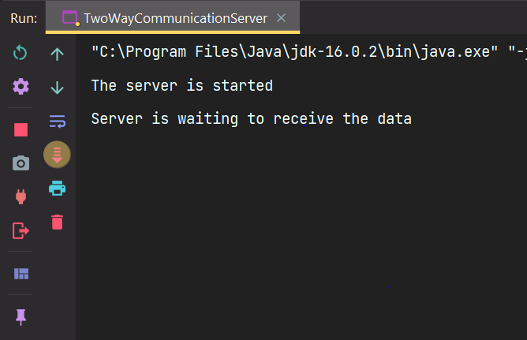
Entering the data in the client:
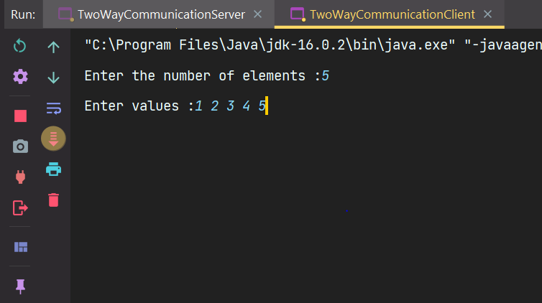
Server processing the received data :
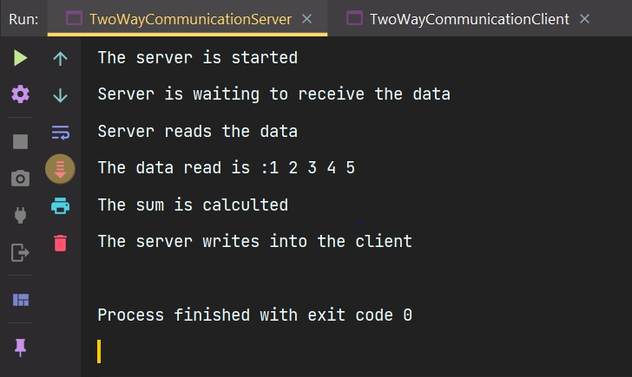
Final result shown in client :
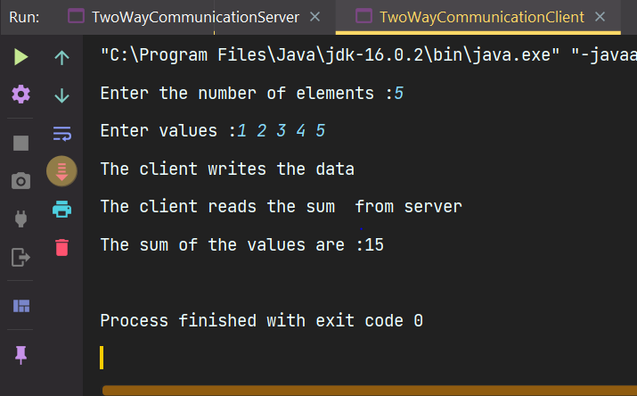

RESULT: Thus, the program has been executed successfully

2)AIM:
To write a java program in which we create a chat application between client and server via TCP Protocol
ALGORITHM:
Client side:
- Read the message from the user through a scanner
- Send it the output port of the server through OutputStreamClass
- Receive the message from inputStreamClass and print this process goes on until we send bye;
Server side:
- Read the message from the client through InputStream class and print it
- Read the message from the server and send it to the client via OutputStreamClass
- This process goes on until we send bye;
PROGRAM CODE:
Client Code:
package Java.SocketProgramming;

import java.io.InputStream;
import java.io.ObjectInputStream;
import java.io.ObjectOutputStream;
import java.io.OutputStream;
import java.net.Socket;
import java.util.Scanner;

public class ChatAppClient1 {
private static Scanner input = new Scanner(System.in);
public static void main(String[] args) throws Exception {
String ipAddress = "192.168.1.18";
int portNumber = 9999;
Socket socket = new Socket(ipAddress , portNumber);
OutputStream outputStream = socket.getOutputStream();
ObjectOutputStream objectOutputStream = new ObjectOutputStream(outputStream);
InputStream inputStream = socket.getInputStream();
ObjectInputStream objectInputStream = new ObjectInputStream(inputStream);
while(true){
System.out.print("Client :");
String msg,msgReceive;
msg = input.nextLine();
objectOutputStream.writeObject(msg);
msgReceive = (String) objectInputStream.readObject();
System.out.println("Server : " + msgReceive);
if(msg.toLowerCase().contains("bye") && msgReceive.toLowerCase().contains("bye")){
System.out.println("Client chat ended ");
break;
}
}
}
}
Server Code:
package Java.SocketProgramming;

import java.io.InputStream;
import java.io.ObjectInputStream;
import java.io.ObjectOutputStream;
import java.io.OutputStream;
import java.net.ServerSocket;
import java.net.Socket;
import java.util.Scanner;

public class ChatAppServer1 {
private static Scanner input = new Scanner(System.in);
public static void main(String[] args) throws Exception {
System.out.println("Server has started , server waiting for client calls");
ServerSocket serverSocket = new ServerSocket(9999);
Socket socket = serverSocket.accept();
OutputStream outputStream = socket.getOutputStream();
ObjectOutputStream objectOutputStream = new ObjectOutputStream(outputStream);
InputStream inputStream = socket.getInputStream();
ObjectInputStream objectInputStream = new ObjectInputStream(inputStream);
while(true){
String msgReceived,msg;
msgReceived = (String)objectInputStream.readObject();
System.out.println("Client :" + msgReceived);
System.out.print("Server :");
msg = input.nextLine();
if(msgReceived.toLowerCase().contains("bye")){
objectOutputStream.writeObject(msg);
break;
}
objectOutputStream.writeObject(msg);
}
}
}

OUTPUT:
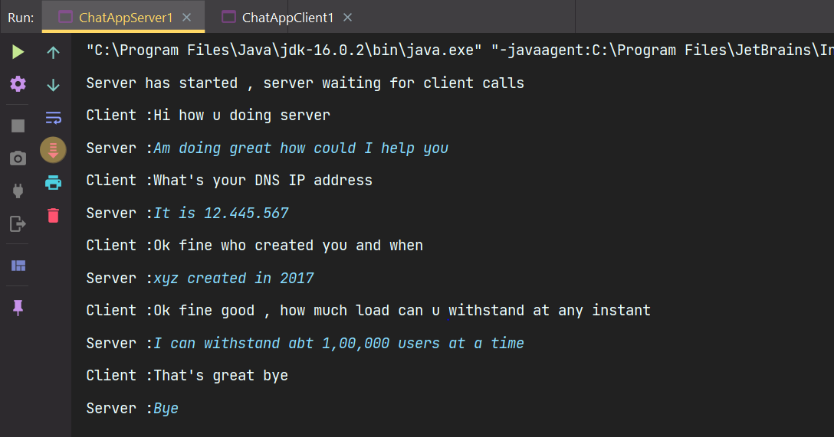
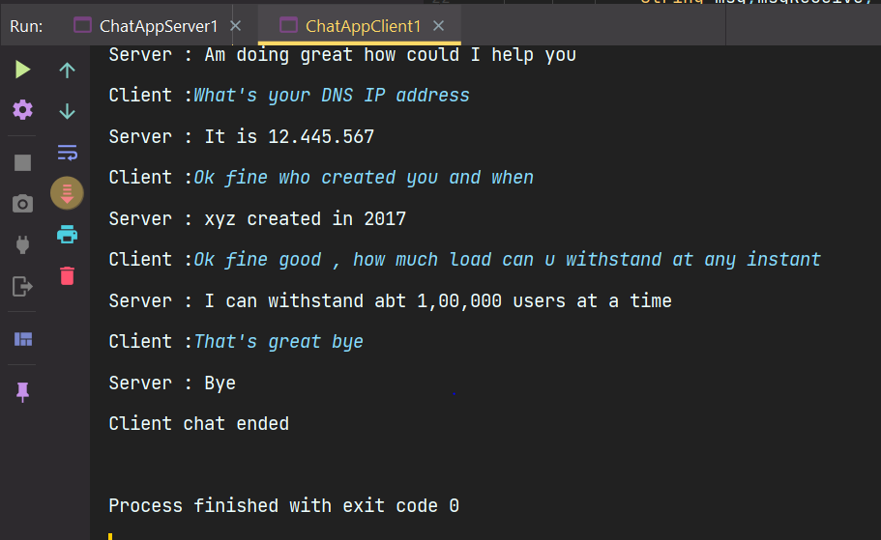

RESULT:
Thus, the program has been executed successfully.
3)AIM:
To write a Java Program for implementing echo client and echo server interaction via UDP Protocol
ALGORITHM:
Client Side:
- Write a message that the client can interact with the server from now
- Read the message from the client side
- Convert the string literal to byte array
- Get the localhost from InetAddress class
- Create a datagram socket object handle it since it throws exception
- Create a datagram packet object and pass the byte array ,it’s length,Inetaddress and port number as args to the constructor
- Pass the datagramPacket object as the parameter to the send method of the datagram socket class
- Create a new data packet for receiving and use the receive method of the datagram socket class
- Convert it to a string and display the message from the server
Server Side:
- Write a message that the server is ready to receive the data packets from the client.
- Get the localhost from InetAddress class
- Create a datagram socket object handle it since it throws exception
- Create a datagram packet object and receive the message as bytes from the client using the receive method of the datagram socket class.
- Convert the received message to strings and print it
- Read the message from the server side and convert it into the byte array
- Create a new datagram packet for sending the data to the client and send the converted byte array,it’s length,inetAddress and port number
PROGRAM CODE:
Client Code:
package Java.SocketProgramming;

import javax.xml.crypto.Data;
import java.net.DatagramPacket;
import java.net.DatagramSocket;
import java.net.InetAddress;
import java.util.Scanner;

public class UDPEchoClient {
private static final Scanner input = new Scanner(System.in);
private static final int PORT_NUMBER = 9999;
public static final String ANSI_YELLOW = "\u001b[33m";
public static final String ANSI_PURPLE = "\u001B[35m";
public static final String ANSI_GREEN = "\u001B[32m";
public static void main(String[] args) throws Exception{
System.out.println(ANSI_YELLOW + "The client can start a conversation with the server");
String msg;
System.out.print(ANSI_PURPLE + "Enter a string message :");
msg = input.nextLine();
DatagramSocket datagramSocket = new DatagramSocket();
byte []msgArray = msg.getBytes();
InetAddress inetAddress = InetAddress.getLocalHost();
DatagramPacket datagramPacket = new DatagramPacket(msgArray, msgArray.length,inetAddress,PORT_NUMBER);
datagramSocket.send(datagramPacket);
byte [] msgReceivedArray = new byte[1024];
DatagramPacket datagramPacket1 = new DatagramPacket(msgReceivedArray, msgReceivedArray.length);
datagramSocket.receive(datagramPacket1);
String msgReceived = new String(datagramPacket1.getData(),0,datagramPacket1.getLength());
System.out.println(ANSI_YELLOW + "The message received from server :" + ANSI_GREEN + msgReceived);
}
}
Server Code:
package Java.SocketProgramming;

import java.net.DatagramPacket;
import java.net.DatagramSocket;
import java.net.InetAddress;
import java.util.Scanner;

public class UDPEchoServer {
private static final Scanner input = new Scanner(System.in);
private static final int PORT_NUMBER = 9999;
public static final String ANSI_YELLOW = "\u001b[33m";
public static final String ANSI_PURPLE = "\u001B[35m";
public static final String ANSI_GREEN = "\u001B[32m";
public static void main(String[] args) throws Exception{
System.out.println(ANSI_YELLOW + "The server is started and ready to receive the packets from the client side");
DatagramSocket datagramSocket = new DatagramSocket(PORT_NUMBER);
byte []msgReceivedArray = new byte[1024];
DatagramPacket datagramPacket = new DatagramPacket(msgReceivedArray, msgReceivedArray.length);
datagramSocket.receive(datagramPacket);
String msgReceived = new String(datagramPacket.getData(),0,datagramPacket.getLength());
System.out.println(ANSI_PURPLE + "The message received from client is :" +ANSI_GREEN + msgReceived);
System.out.print("Enter your message :");
String msg = input.nextLine();
byte[] msgArray = msg.getBytes();
InetAddress inetAddress = InetAddress.getLocalHost();
DatagramPacket datagramPacket1 = new DatagramPacket(msgArray, msgArray.length,inetAddress,datagramPacket.getPort());
datagramSocket.send(datagramPacket1);
}
}
OUTPUT:
Run the Server file and then client file
Initial run of the server file:
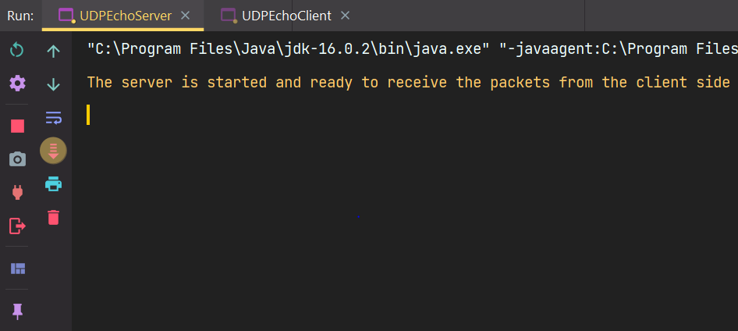
Intial Run of the client file :
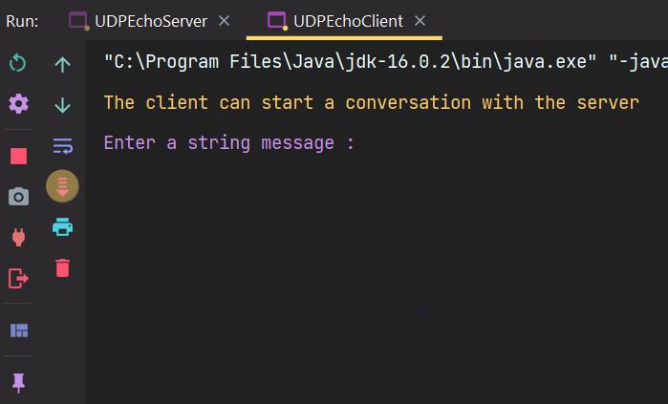

Final Result after displaying the message from client in the server file
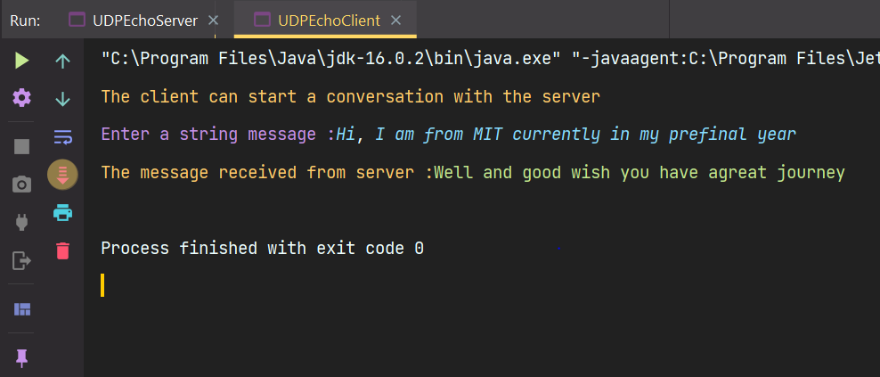
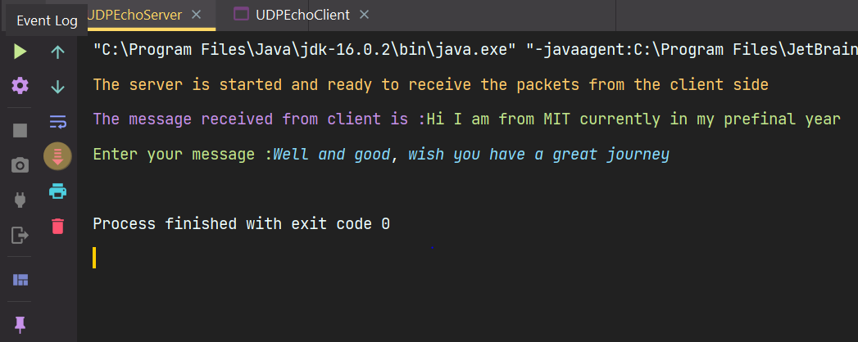

RESULT:
Thus the program has been executed successfully.

4)AIM:
To write a Java Program for implementing echo client and echo server interaction via UDP Protocol

ALGORITHM:
Client Side:
- Write a message that the client can interact with the server from now
- Read the number of elements to be read from the user and create a byte array of that size
- Read the values from the user.
- Get the localhost from InetAddress class
- Create a datagram socket object handle it since it throws exception
- Create a datagram packet object and pass the byte array ,it’s length,Inetaddress and port number as args to the constructor
- Pass the datagramPacket object as the parameter to the send method of the datagram socket class
- Create a new data packet for receiving and use the receive method of the datagram socket class
- Convert it to a string and display the message from the server.
Server Side:
- Write a message that the server is ready to receive the data packets from the client.
- Get the localhost from InetAddress class
- Create a datagram socket object handle it since it throws exception
- Create a datagram packet object and receive the message as bytes from the client using the receive method of the datagram socket class.
- Fint the sum of the byte array that we received from the client side.
- Convert it to a string and then to a byte array which holds the sum of the entire byte array
- Create a new datagram packet for sending the data to the client and send the converted byte array,it’s length,inetAddress and port number.

PROGRAM CODE:
Client Code:
package Java.SocketProgramming;
import java.net.DatagramPacket;
import java.net.DatagramSocket;
import java.net.InetAddress;
import java.util.Scanner;

public class UDPClient1 {
private static final Scanner input = new Scanner(System.in);
public static final String ANSI_YELLOW = "\u001b[33m";
public static final String ANSI_PURPLE = "\u001B[35m";
public static final String ANSI_GREEN = "\u001B[32m";
public static void main(String[] args) throws Exception {
System.out.println(ANSI_YELLOW + "The server is started and ready to receive the packets from the client side");
DatagramSocket datagramSocket = new DatagramSocket();
int n;
System.out.print(ANSI_PURPLE + "Enter the number of elements :");
n = input.nextInt();
byte []arr = new byte[n];
System.out.print(ANSI_PURPLE + "Enter elements :");
for(int i = 0 ; i < n ; i++)arr[i] = input.nextByte();
InetAddress inetAddress = InetAddress.getLocalHost();
System.out.println(ANSI_YELLOW + "The data packet is sending ....");
DatagramPacket datagramPacket = new DatagramPacket(arr,arr.length,inetAddress,9999);
datagramSocket.send(datagramPacket);
byte [] receivedData = new byte[1024];
DatagramPacket datagramPacket1 = new DatagramPacket(receivedData,receivedData.length);
datagramSocket.receive(datagramPacket1);
System.out.println(ANSI_YELLOW + "The data processed is being received ");
String res = new String(datagramPacket1.getData(),0,datagramPacket1.getLength());
System.out.println(ANSI_PURPLE + "The result is :" + res);

}
}
Server Code:
package Java.SocketProgramming;

import java.net.DatagramPacket;
import java.net.DatagramSocket;
import java.net.InetAddress;

public class UDPServer1 {
public static final String ANSI_YELLOW = "\u001b[33m";
public static final String ANSI_PURPLE = "\u001B[35m";
public static final String ANSI_GREEN = "\u001B[32m";
public static void main(String[] args)throws Exception {
System.out.println(ANSI_YELLOW + "The server is started and ready to receive the packets from the client side");
DatagramSocket datagramSocket = new DatagramSocket(9999);
byte [] receivedArray = new byte[1024];
DatagramPacket datagramPacket = new DatagramPacket(receivedArray,receivedArray.length);
datagramSocket.receive(datagramPacket);
System.out.println("The data packet is received...");
receivedArray = datagramPacket.getData();
int n = datagramPacket.getLength();
int sum = 0;
System.out.println(ANSI_PURPLE + "The data received is :");
for(int i = 0 ; i < n ; i++)System.out.print(receivedArray[i] + " ");
System.out.println();
for(int i = 0 ; i < n ; i++)sum = sum + receivedArray[i];
byte [] calArray = String.valueOf(sum).getBytes();
InetAddress inetAddress = InetAddress.getLocalHost();
DatagramPacket datagramPacket1 = new DatagramPacket(calArray,calArray.length,inetAddress,datagramPacket.getPort());
System.out.println(ANSI_YELLOW + "The data is processed and it is sending back to the client...");
datagramSocket.send(datagramPacket1);
}
}
OUTPUT:
Initial run of the server:
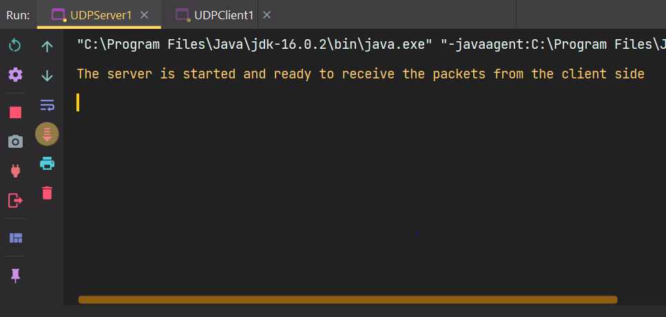

Intial run of the client:
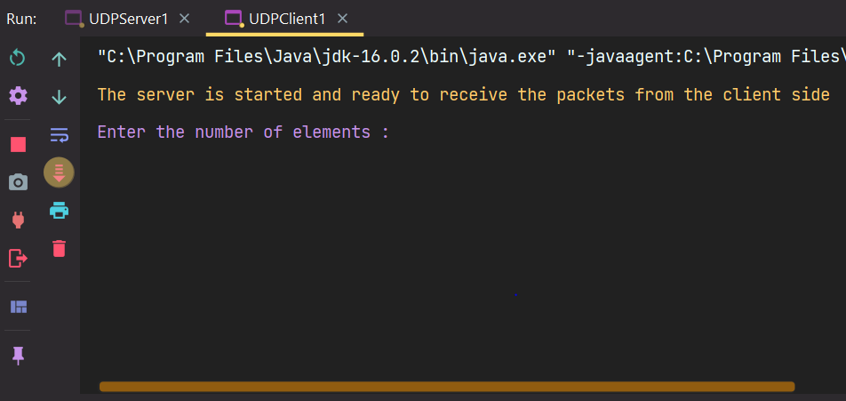
Server processing the received data :
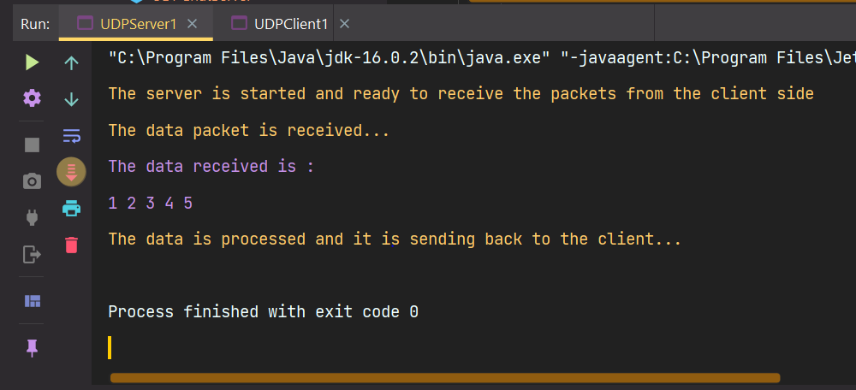
Final result shown in client :
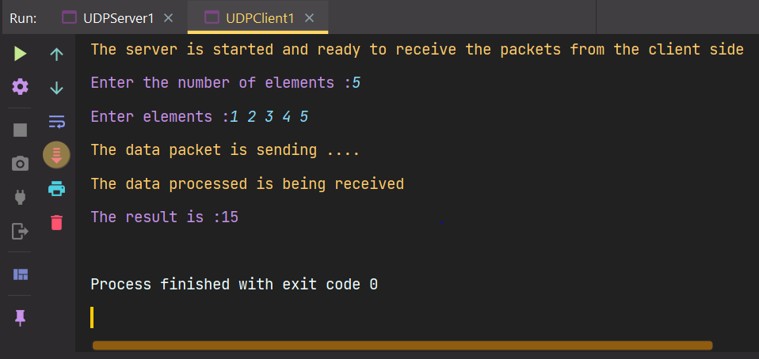

RESULT: Thus, the program has been executed successfully

